**RDS Features:**

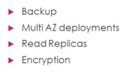

**Backup:**

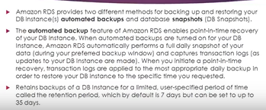

**Explanation:**

When it comes to data base Backup and Restore are very critical. Think about an organization has a sophisticated data which is very critical to their business, what happens if anything wrong goes with the data base or if you rollback on database, in those scenarios backup and restore are very important.

In amazon, we have these 2 options namely automated backups and database snapshots to help on taking care of these requirements.

Amazon RDS provides 2 different methods for backup and restore that data in database instance.

1. Automated backups, 2. Database snapshots

Automated backups:

The automated backup feature of amazon RDS enables point- in- time recovery of your DB instance means Amazon they run or they manage every backup activity for us.

Amazon will take daily backups same time they will capture transaction logs, so whenever there is any activity happening in our data base, it will get added or it will do transaction log.

So, daily backups and transactional logs will be done and we can define a restore period to find the date and time and even seconds when amazon stores the database to that point in time.

When automated database backup are turned on for data base instance, amazon RDS automatically performs full daily snapshots of our data and captures the transaction logs.

When we initiate a time point of recovery, they are applied to most of the daily backups and helps to restore our data base instance to a specific time that we requested.

Read above 3rd point in snipping shot about Retention period.

DB snapshots:

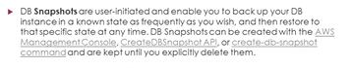

Explanation: If we want to create our own snapshots, we can do, we can define our own time,

Depends upon project requirement.

RDS Multi AZ: